**International School, Duy Tan University**



CAPSTONE PROJECT 2

AN PHU FARM SYSTEM

**PROJECT PLAN DOCUMENT**

Version 1.0

30/01/2016

**Mentor : MSc. Nguyen Minh Nhat**

**Group name : Divine Team**

**Document Information**

|  |  |
| --- | --- |
| Project | An Phu Farm System |
| Document Title | User Manual |
| Creator | Doan Hai Dang |

**Revision History**

|  |  |  |  |
| --- | --- | --- | --- |
| Version | Person | Date | Description |
| 1.0 | Doan Hai Dang | 12- April - 2016 | Draft |
|  |  |  |  |
|  |  |  |  |

**Document Approval**

The following signatures are required for approval of this document

**Prepared by**

Doan Hai Dang Date

*Team Leader 12/04/2016*

Contents

**1.** **MASTER INTERFACE** 5

**2.1.** **Guest Window** 5

**2.2.** **“Register” Form** 6

**2.3.** **“Login” Form** 7

**2.3.** **“Product” Form** 9

**2.4.1.** **For Web** 9

**2.4.2.** **For App** 9

**2.4.** **“Contact” Form** 10

**3.** **MEMBER INTERFACE** 11

**5.** **SCAN BARCODE** 15

**6.** **CHAT SEVER** 16

**7.** **SEARCH PRODUCT** 17

**7.1.** **By web** 17

1. **MASTER INTERFACE**

Table 1. Homepage

|  |  |  |  |  |
| --- | --- | --- | --- | --- |
| From | ID | Action | Target | Result |
| Homepage | 1 |  | Replace window | Register account |

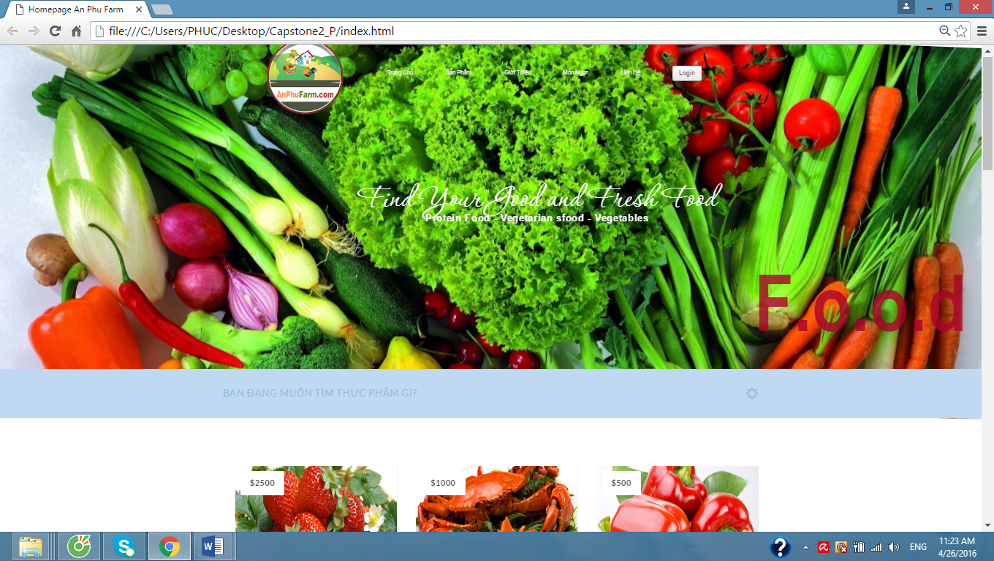

Figure 1. Homepage

1. **GUEST WINDOW**
   1. **Guest Window**

Table 2.1. Guest Window

|  |  |  |  |  |
| --- | --- | --- | --- | --- |
| From | ID | Action | Target | Result |
| “Tạo Tài Khoản” button | 2 | Click | Replace window | Register account |
| “Đăng Nhập” page | 3 |  |  |  |
| “Bạn quên mật khẩu của mình?” Link | 4 | Click | Retrieve password | Replace window |
| “Đồng ý” | 5 | Click | Register | Replace window |



Figure 2.1. Guest Window

* 1. **“Register” Form**

Table 2.2. Register

|  |  |  |  |  |  |
| --- | --- | --- | --- | --- | --- |
| From | ID | Action | Target |  | Result |
| “Register” form | 6 |  |  |  |  |
| “Tôi đã đọc và đồng ý với điều khoản qui định. Tạo tài khoản ” button | 7 | Click | Register |  | If true:  Display the message“ bạn đã đăng ký thành công”  Else  Display the message ”bạnkhông đăng ký thành công” and request enter |
| “ Hủy tất cả” button | 8 | Click |  |  | Replace window |

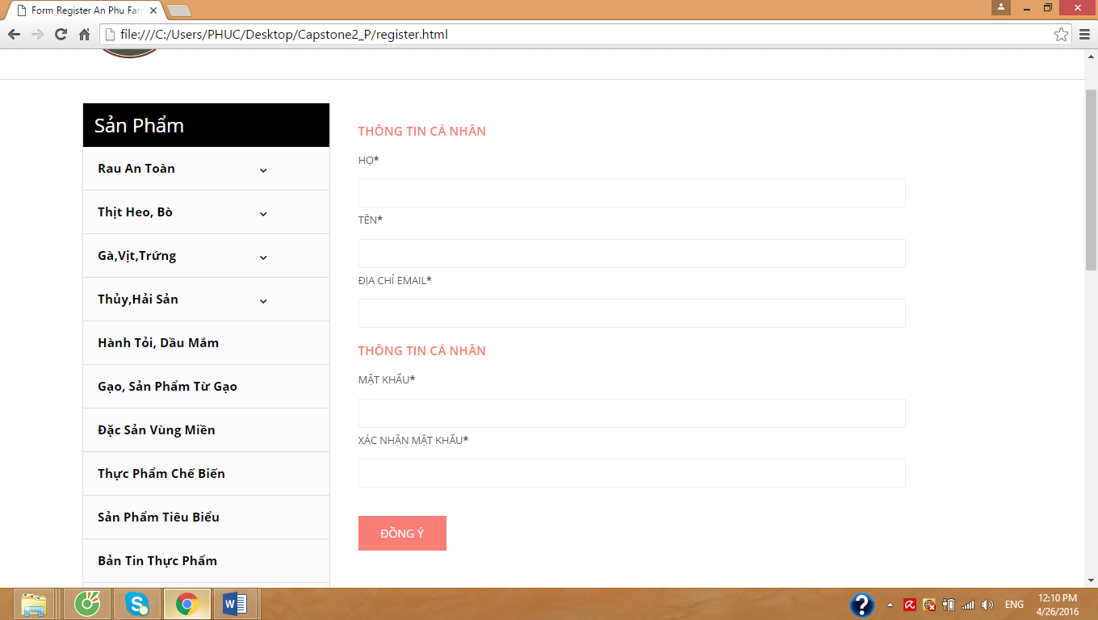

Figure 2.2. Register

* 1. **“Login” Form**

Table 2.3. Login

|  |  |  |  |  |
| --- | --- | --- | --- | --- |
| From | ID | Action | Target | Result |
| “Đăng Nhập” Form | 9 |  |  |  |
| “Đăng nhập” button | 10 | Click | Login | If correct  Display your information  Else  Display message “ Bạn đã nhập sai Tên Truy Cập hoặc Mật Khẩu” |
| “Bạn quên mật khẩu của mình” Link | 11 | Click | Retrieve password | Replace window |
| “Tạo tài khoản” Button | 12 | Click | Register | Replace window |

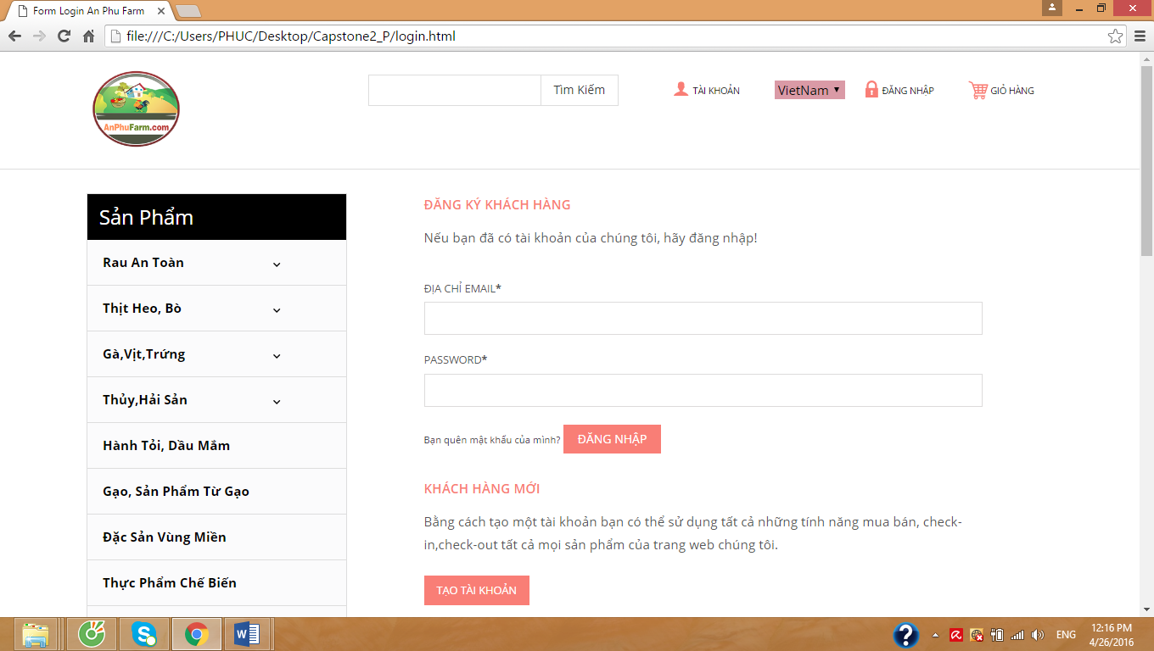

Figure 2.3. Login

* 1. **“Product” Form**

**2.4.1. For Web**

Table 2.3. Product For Web

|  |  |  |  |  |
| --- | --- | --- | --- | --- |
| From | ID | Action | Target | Result |
| “Product” form |  |  |  |  |
| “Sản Phẩm” button | 13 | Click | Display list of products | Replace the products page |

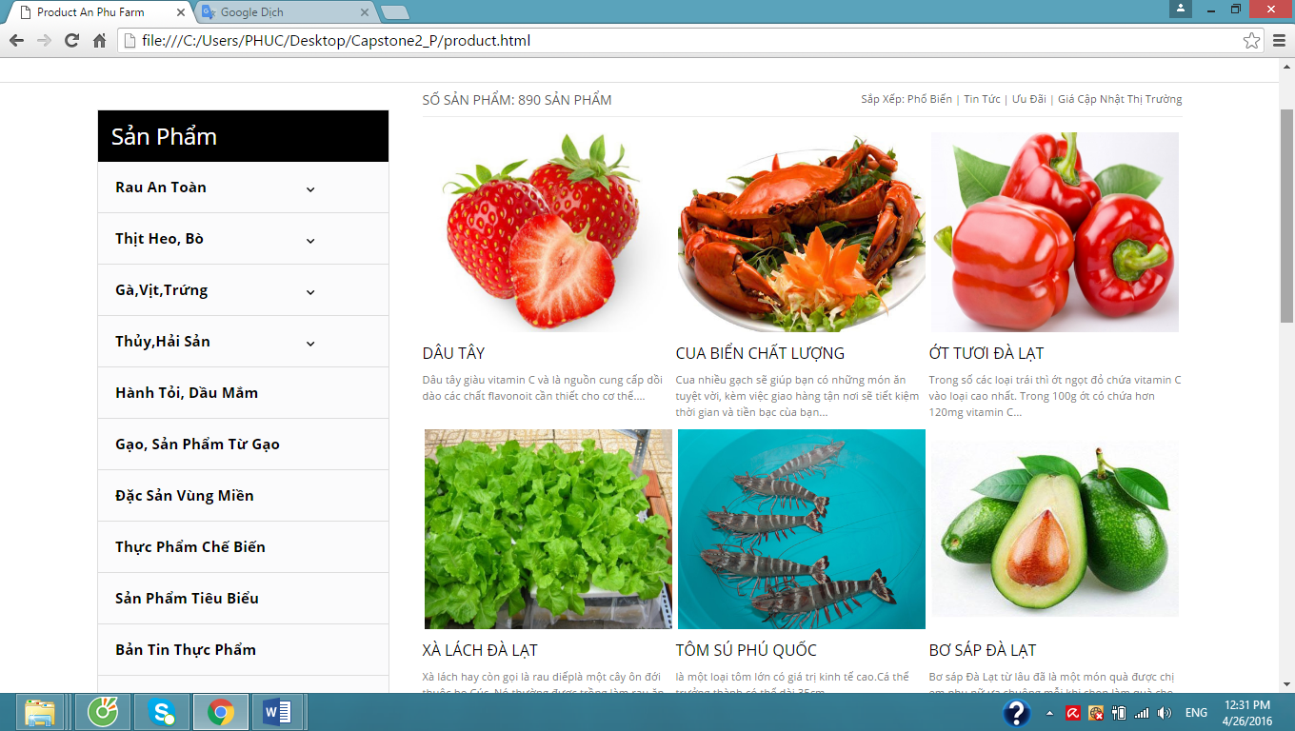

Figure 2.3. Product For Web

### **2.4.2. For App**

Table 2.3. Product For App

|  |  |  |  |  |
| --- | --- | --- | --- | --- |
| From | ID | Action | Target | Result |
| “Product” form | 14 |  |  |  |
| “Plus” button | 15 | Click | Add product from cart | Add product in cart |
| “Plus” button | 16 | Click | Minus product from cart | Minus product from cart |
| “Cart” image button | 17 | Click | Replace the User ‘s purchase history page |  |

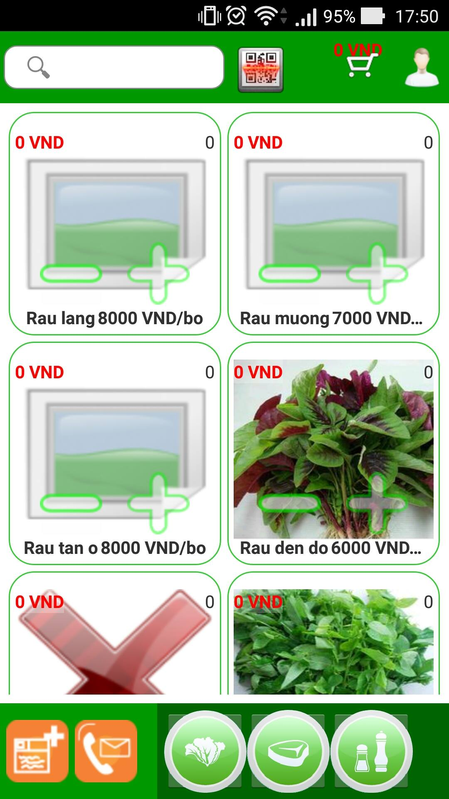

Figure 2.3. Product For App

* 1. **“Contact” Form**

Table 2.4. Contact

|  |  |  |  |  |
| --- | --- | --- | --- | --- |
| From | ID | Action | Target | Result |
| “Contact” form | 18 |  |  |  |
| “Liên Hệ” button | 19 | Click | Display the information contact page | Replace the contact page |
| “Gửi” button | 20 | Click | User ‘s information will be send to the system | Replace the contact page |

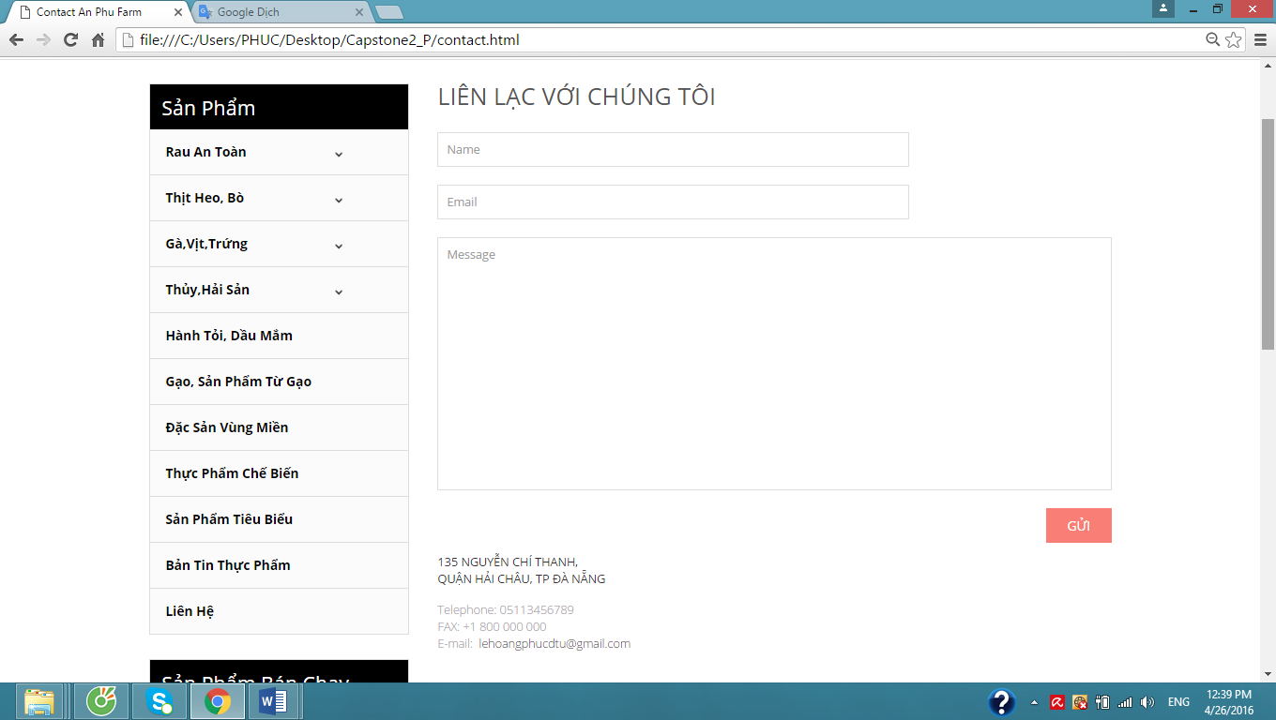

Figure 2.4. Contact

1. **MEMBER INTERFACE**

Table 3. Member Interface

|  |  |  |  |  |
| --- | --- | --- | --- | --- |
| From | ID | Action | Target | Result |
| “Member Interface” form | 21 |  |  |  |
| “Liên Hệ” button | 22 | Click | Display the information contact page | Replace the contact page |
| “Thông tin thêm” button | 23 | Click | User ‘s information will be shown | Replace the information page |
| “Địa chỉ” button | 24 | Click | User ‘s address will be shown | Replace the information page |
| “Hình ảnh” button | 25 | Click | User ‘s images will be shown | Replace the information page |
| “Giới thiệu” button | 26 | Click | User ‘s introduction about users will be shown | Replace the information page |
| “Lịch sử mua hàng” button | 27 | Click | User ‘s purchase history about users will be shown | Replace the information page |
| “Doanh số bán hàng” button | 28 | Click | Information about the number of sales will be shown | Replace the information page |
| “Video” button | 29 | Click | Some videos of the shop will be shown for user | Replace the information page |

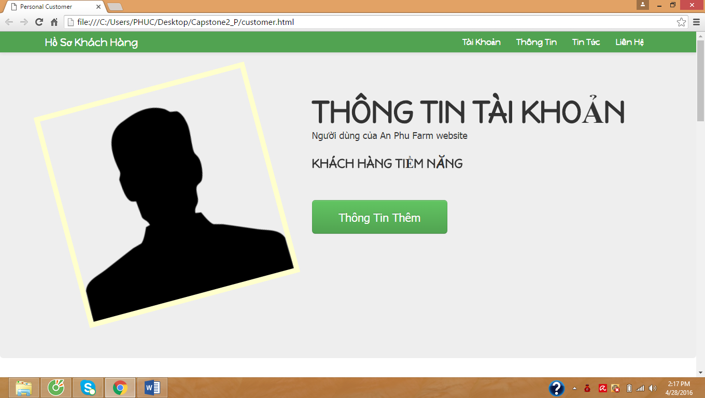

Figure 3. Member Interface

1. **ADMIN INTERFACE**

Table 4. Admin Interface

|  |  |  |  |  |
| --- | --- | --- | --- | --- |
| From | ID | Action | Target | Result |
| “Admin interface” form | 30 |  |  |  |
| “Create new Category” button | 31 | Click | Display the new product form | Display the new product form |
| “Save” button | 32 | Click | Save the new product form | Save the new product form |
| “Create new Customer” button | 33 | Click | Display the new customer form | Display the new product form |
| “List all Customer” button | 34 | Click | Display the list all customer | Display the list all customer |

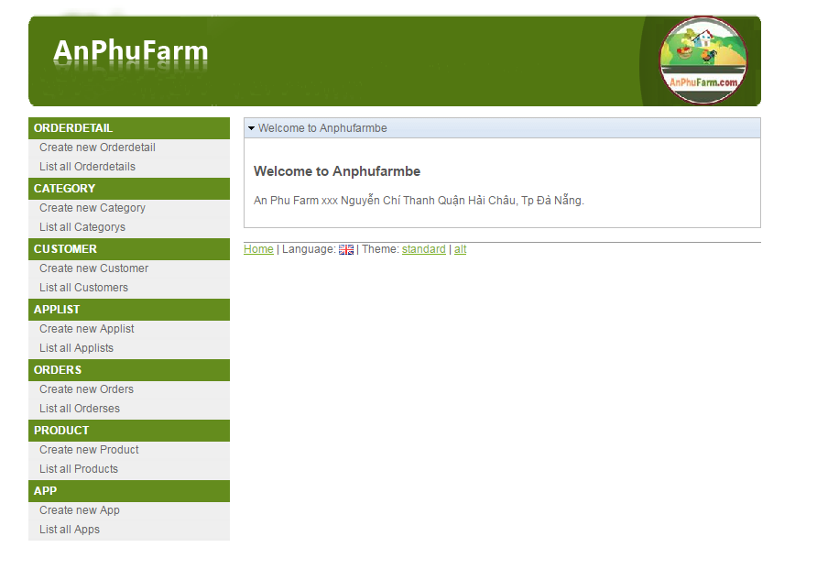

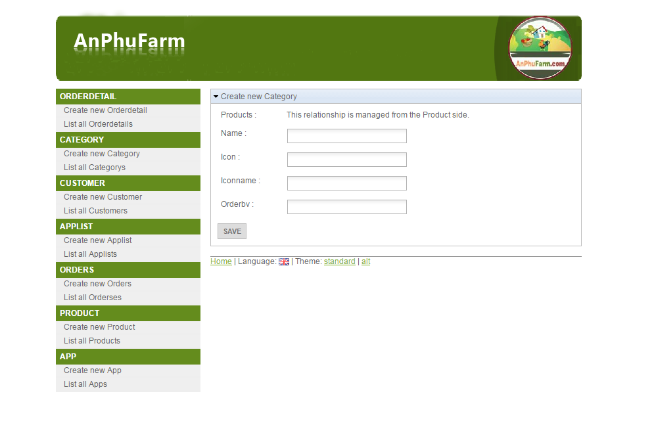

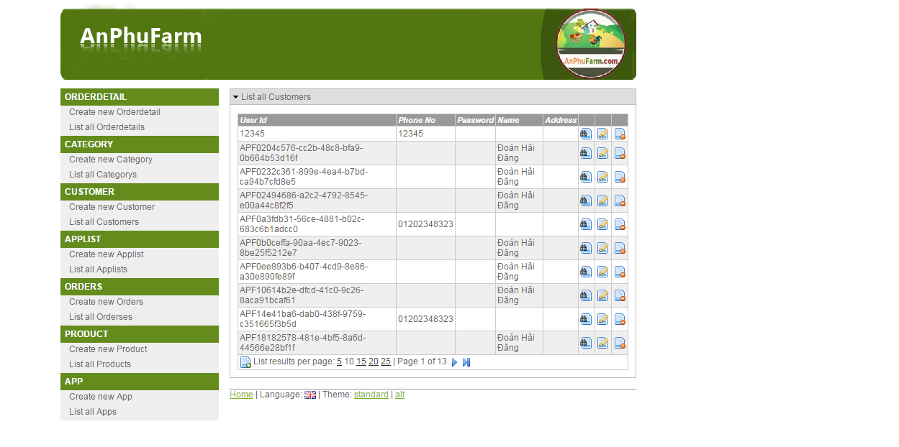

Figure 4. Admin Interface

1. **SCAN BARCODE**

Table 5. Scan Barcode

|  |  |  |  |  |
| --- | --- | --- | --- | --- |
| From | ID | Action | Target | Result |
| “Scan Barcode” form | 35 |  |  |  |
| “Product search” button | 36 | Click | Display product by barcode | Display product by barcode |
| “Web search” button | 37 | Click | Search product by barcode from web | Search product by barcode from web |

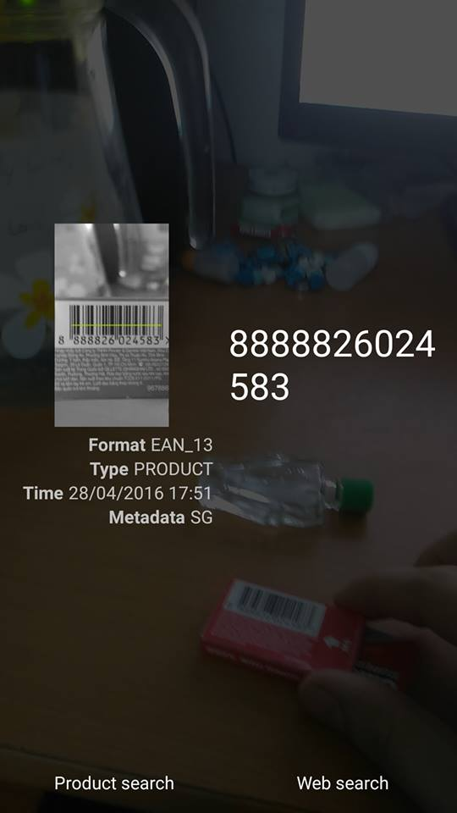

Figure 5. Scan Barcode

1. **CHAT SEVER**

Table 6. Chat Sever

|  |  |  |  |  |
| --- | --- | --- | --- | --- |
| From | ID | Action | Target | Result |
| “Chat Sever” form | 38 |  |  |  |
| “Send” button | 39 | Click | Respond the request a call to sever | Respond the request a call to sever |

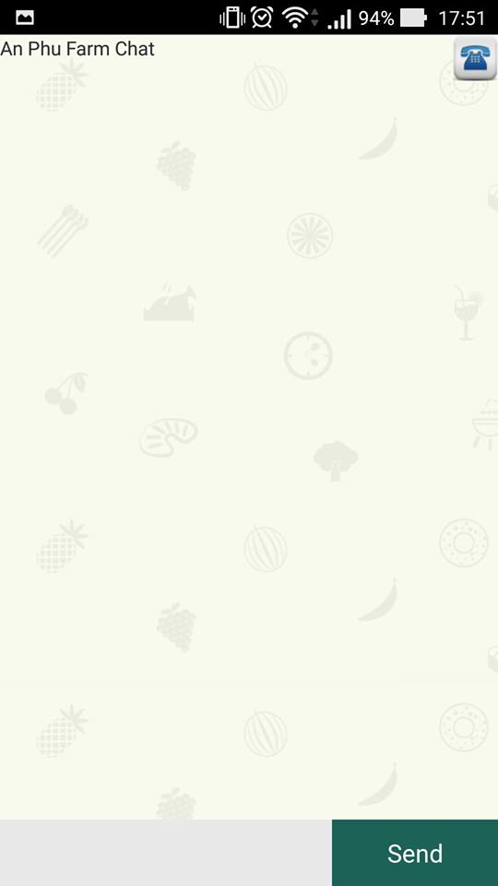

Figure 6. Chat Sever

1. **SEARCH PRODUCT**
   1. **By web**

Table 7.1. Search Product By Web

|  |  |  |  |  |
| --- | --- | --- | --- | --- |
| From | ID | Action | Target | Result |
| “Search Product” form | 40 |  |  |  |
| “Tìm Kiếm” button | 41 | Click | Display product base on name | Display product base on names |

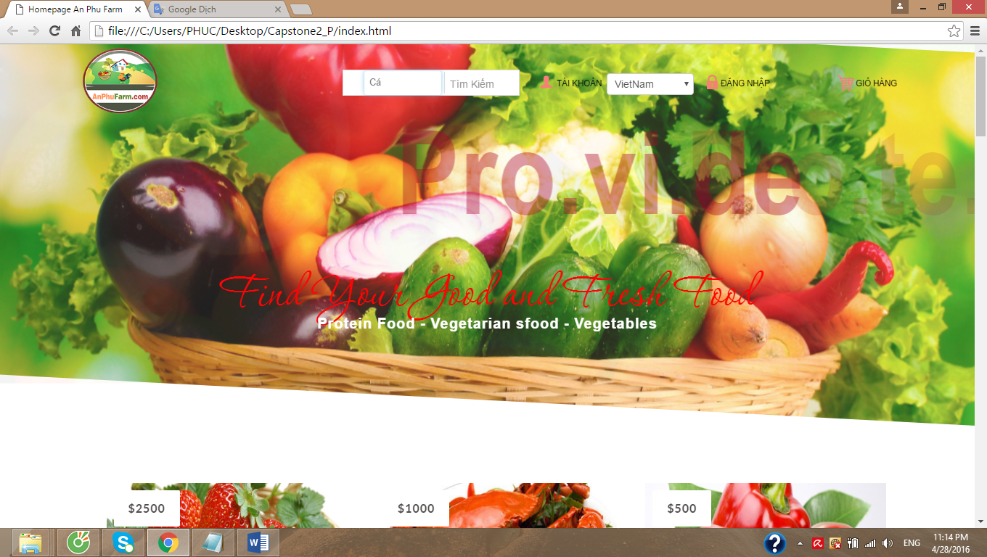

Figure 7.1 Search Product By Web

* 1. **By app**

Table 7.2. Search Product By App

|  |  |  |  |  |
| --- | --- | --- | --- | --- |
| From | ID | Action | Target | Result |
| “Search Product” form | 42 |  |  |  |
| “Tìm Kiếm” button | 43 | Click | Display product base on name | Display product base on name |

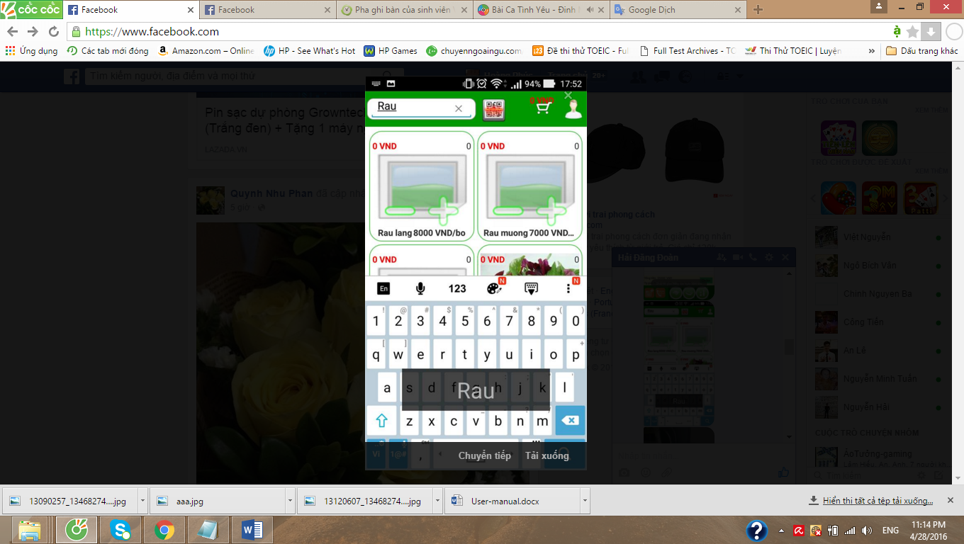

Figure 7.2 Search Product By App

|  |  |  |
| --- | --- | --- |
| ***Prepared by*** | ***Signature*** | ***Date*** |
| Doan Hai Dang  Mr    K18CMUTPM1 | | / / |
| Le Hoang Phuc  Mr    K18CMUTPM1 | | / / |
| Le Dinh Doan  Mr  K18CMUTPM1 | | / / |
| Nguyen Ba Chinh  Mr  K18CMUTPM1 | | / / |
| ***Approved by*** | ***Date*** | ***Signature*** |
| Nguyen Minh Nhat  Msc, Mentor  Duy Tan University | | / / |